Lect-2 Pediatric Dentistry Dr. Baydaa Ali

  - Factors that Cause Difference in Time of Eruption:
1. Race: different studies showed that the Negro have their teeth erupted earlier than white people.
2. Environment: eruption in industrial countries children is later than rural children as they eat soft and ready made food.
3. Socio – economic Level: The children of high level show early teeth eruption due to good nourishment and health.
4. Nutrition and Growth: result in earlier teeth eruption
5. Sex: female’s teeth eruption earlier than males.
6. Disease: either local or systemic disease.

Local Factors:
1. Infection around the tooth: when there is infection in the erupted tooth area near the eruption time, there will be an early eruption because of the tearing of the soft tissue and sometimes even there is bone resorption. While in case of infection around the erupting tooth before a long time of its normal eruption there will be healing and fibrosis of the area that’s cause delay eruption of this tooth.
2. Supernumerary teeth: lead to delay eruption due to impaction.
3. Trauma: any trauma may cause early shedding of deciduous that’s result in late eruption of permanent successor.
4. Gingival fibromatosis: very hard tissue of the gum, it is hereditary condition that prevent normal eruption process and the treatment is by gingivectomy.
5. Ankylosed teeth: The tooth is in state of static retention, whereas in the adjacent areas eruption and alveolar growth continue. The term infraocclusion although commonly used today.

Ankylosed Primary Teeth:
The problem of ankylosed primary molars deserves much attention by dentists. Application of the term submerged molar to this condition is inaccurate, even though the tooth may appear to be submerging into the
mandible or maxilla. This misconception results from the fact that the ankylosed tooth is in a state of static retention, whereas in the adjacent areas eruption and alveolar growth continue. The term infraocclusion, although commonly used today, in the authors' opinions is not preferable to ankylosis.

The diagnosis of an ankylosed tooth is not difficult to make. Because eruption has not occurred and the alveolar process has not developed in normal occlusion, the opposing molars in the area seem to be out of occlusion.
The ankylosed tooth is not mobile, even in cases of advanced root resorption. Ankylosis can be partially confirmed by tapping the suspected tooth and an adjacent normal tooth with a blunt instrument and comparing the sounds. The ankylosed tooth will have a solid sound, whereas the normal tooth will have a cushioned sound because it has an intact periodontal membrane that absorbs some of the shock of the blow.
The radiograph is often a valuable aid in making a diagnosis. A break in the continuity of the periodontal membrane indicating an area of ankylosis is often evident radiographically.

In the management of an ankylosed tooth, early recognition and diagnosis are extremely important. The eventual treatment may involve surgical removal. However, unless a caries problem is unusual or loss of arch length is evident, the dentist may choose to keep the tooth under observation. A tooth that is definitely ankylosed may at some future time undergo root resorption and be normally exfoliated. When patient cooperation is good and recall periods are regular, a watchful waiting approach is best.

Ankylosed Permanent Teeth:
The incomplete eruption of a permanent molar may be related to a small area of root ankylosis. The removal of soft tissue and bone covering the occlusal aspect of the crown should be attempted first, and the area should be packed with surgical cement to provide a pathway for the developing permanent tooth.
If the permanent tooth is exposed in the oral cavity and at a lower occlusal plane than the adjacent teeth, ankylosis is the probable cause. A luxation technique effective in breaking the bony ankyloses. If the rocking technique is not immediately successful, it should be repeated in 6 months. A delay in treatment may result in a permanently ankylosed molar.
Unerupted permanent teeth may become ankylosed by inostosis of enamel. The process follows the irritation of the follicular or periodontal tissue resulting from chronic infection." The close association of an infected apex to an unerupted tooth may give rise to the process. In the unerupted tooth, enamel is protected by enamel epithelium. The enamel epithelium may disintegrate as a result of infection (or trauma), the enamel may subsequently be resorbed, and bone or coronal cementum may be deposited in its place. The result is solid fixation of the tooth in its unerupted position

Systemic Diseases:
TRISOMY 21 SYNDROME (DOWN SYNDROME)

Trisomy 21 syndrome (Down syndrome [DS]) is one of the congenital anomalies in which delayed eruption of the teeth frequently occurs. The first primary teeth may not appear until 2 years of age, and the dentition may not be complete until 5 years of age. The eruption often follows an abnormal sequence, and some of the primary teeth may be retained until 15 years of age.

CLEIDOCRANIAL DYSPLASIA
A rare congenital syndrome that has dental significance is cleidocranial dysplasia (CCD), which has also been referred to as cleidocranial dysostosis, osteodentin dysplasia, mutational dysostosis, and Marie-Sainton syndrome.
Transmission of the condition is by either parent to a child of either sex. The diagnosis is based on the finding of an absence of clavicles, although there may
be remnants of the clavicles, as evidenced by the presence of the sternal and acromial ends. The fontanels are large, and radiographs of the head show open
sutures, even late in the child's life. The sinuses, particularly the frontal sinus, are usually small.
The patients exhibited mandibular prognathism caused by increased mandibular lengths and short cranial bases. The maxillae tended to be short vertically but not anteroposteriorly.
The development of the dentition is delayed. Complete primary dentition at 15 years of age resulting from delayed resorption of the deciduous teeth and delayed
eruption of the permanent teeth is not uncommon

HYPOTHYROIDISM
Hypothyroidism is another possible cause of delayed eruption. Patients in whom the function of the thyroid gland is extremely deficient have characteristic dental
findings.
Congenital Hypothyroidism (Cretinism). Hypothyroidism occurring at birth and during the period of most rapid growth, if undetected and untreated, causes mental deficiency and dwarfism. This condition was referred to as cretinism in earlier medical and dental literatures. Congenital hypothyroidism is the result of an
absence or underdevelopment of the thyroid gland and insufficient levels of thyroid hormone. Today it is routinely diagnosed and corrected at birth because of
mandatory blood screening of newborn infants. An inadequately treated child with congenital hypothyroidism is a small and disproportionate person, with abnormally short arms and legs. The head is disproportionately large, although the trunk shows less deviation from the norm. Obesity is common.
Without adequate hormonal therapy the dentition of the child with congenital hypothyroidism is delayed in all stages, including eruption of the primary teeth,
exfoliation of the primary teeth, and eruption of the permanent teeth. The teeth are normal in size but are crowded in jaws that are smaller than normal. The tongue is large and may protrude from the mouth. The abnormal size of the tongue and its position often cause an anterior open bite and flaring of the anterior teeth.
The crowding of the teeth, malocclusion, and mouth breathing cause a chronic hyperplastic type of gingivitis.

Juvenile Hypothyroidism (Acquired Hypothyroidism).
Juvenile hypothyroidism results from a malfunction of the thyroid gland, usually between 6 and 12 years of age. Because the deficiency occurs after the period of rapid growth, the unusual facial and body pattern characteristic of a person with congenital hypothyroidism is not present. However, obesity is evident to a lesser degree. In the untreated case of juvenile hypothyroidism, delayed exfoliation of the primary teeth and delayed eruption of the permanent teeth are characteristic. A child with a chronologic age of 14 years may have a dentition in a stage of development comparable with that of a child 9 or 10 years of age.

HYPOPITUITARISM
A pronounced deceleration of the growth of the bones and soft tissues of the body will result from a deficiency in secretion of the growth hormone. Pituitary dwarfism is the result of an early hypofunction of the pituitary gland.
Again, early diagnosis is routine because of the mandatory blood screening of newborn infants for congenital hypothyroidism.
An individual with pituitary dwarfism is well proportioned but resembles a child of considerably younger chronologic age. The dentition is essentially
normal in size.
Delayed eruption of the dentition is characteristic. In severe cases the primary teeth do not undergo resorption but instead may be retained throughout the
life of the person. The underlying permanent teeth continue to develop but do not erupt. Extraction of the deciduous teeth is not indicated, since eruption of the
permanent teeth cannot be assured. Some degree of cognitive disability often occurs.

ACHONDROPLASTIC DWARFISM
Achondroplastic dwarfism, also diagnosed at birth, demonstrates a few characteristic dental findings. Growth of the extremities is limited because of a lack of calcification in the cartilage of the long bones. Stature improvements have been reported with surgical lengthening of the limbs and also with growth hormone therapy.
The head is disproportionately large, although the trunk is normal in size. The fingers may be of almost equal length, and the hands are plump. The fontanels are open at birth. The upper face is underdeveloped, and the bridge of the nose is depressed.
Although the etiology of achondroplastic dwarfism is unknown, it is clearly an autosomal dominant disorder although sporadic spontaneous mutations occur.

The maxilla may be small, with resultant crow ding of the teeth and a tendency for open bite.The gingivitis is usually present. The development of the dentition was slightly delayed.

Tooth Development
(Odontogenesis)

- Primary dentition – develops during prenatal period
  - 20 teeth
- Permanent dentition – develops as the jaw grows and matures
  - 32 teeth
period in between – during the preteen years
(mixed dentition period)

Tooth Development
A. Bud Stage
B. Cap Stage
C. Bell Stage
D and E. Dentinogenesis and
amelogenesis
F. Crown formation
G. Root Formation and
eruption
H. Function

Initiation of Tooth Development
The initiation of tooth development begins at 37 days of development with formation of a continuous horseshoe-band of thickened epithelium in the location of upper and lower jaws – Primary Epithelial Band
Each band of epithelium will give
rise to 2 sub divisions:
1. Dental lamina and
2. Vestibular lamina

Formation of permanent tooth
- The dental lamina gives off a series of buds, one of which lies on the medial side of each developing milk tooth.
- These buds form the enamel organs.
- They give rise to permanent incisors, canines & premolars.
The permanent molars are formed from buds that arise from the dental lamina posterior to the region of last milk tooth.
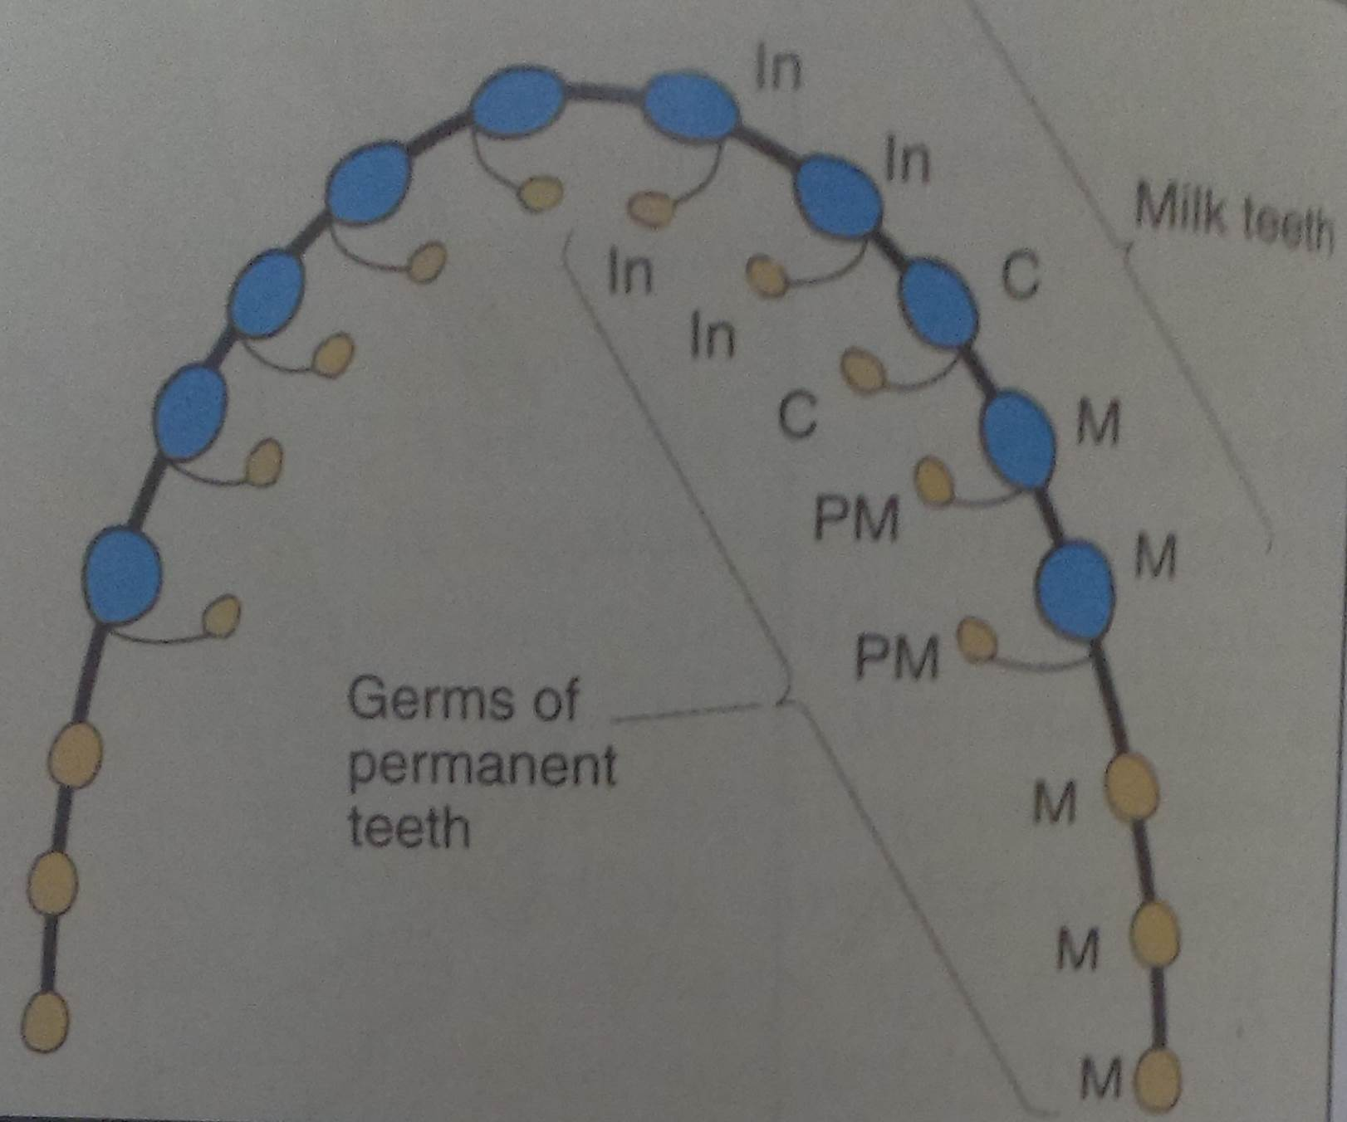

Stages in the life cycle of a tooth
1. Growth
Physiologic process
- Initiation
- Prolifiration
- Histodifferentiation
- Morphodifferentiation
- Apposition
2. Calcification
3. Eruption
4. apposition

Three developmental process before function

- Grow
- Calcify
- Erupt
- Unlike kidney and heart.. Afte growth .. Function
- Unlike bone… growth and calcify… function

- 6th weeks intra uterine life: first sign of tooth development
- Dental lamina: represent the first sign of tooth development. This is the GERMINAL BAND OF EPITHELIUM

Function of dental lamina
- Initiate the development of the whole deciduous dentition
- Initiate the development of the succedenuous teeth, by proliferation of bud from enamel organ
- Initiates the development of the accesional teeth from the distal extention of the dental lamina

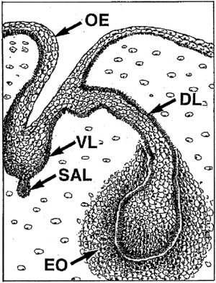
Vestibular lamina

- After the dental lamina, the vestibular lamina will arise as another ectodermal thickening, but anterior to the dental lamina.
- Then this will split to form the vestibular groove the future vestibule.
Fate of dental lamina
- The remnant should be calcified and be resorbed by osteoclast because it has no function
- But, some group of epithelial cells may persist to stay (called gland of serres) and differentiates into ENAMEL MASS, SUPERNUMERARY TEETH, TUMORS OR CYST (ameloblastoma)

